***Challenges:***

***Physical:*** Saena primarily faces the physical challenges;

As a traveling merchant’s daughter, she has learned to

Fight; she faces the dark Fae but suffers weakness in her

Mental defenses against their magic; Aerim learns to

Fight from Saena and help her learn to defend herself

Mentally

.

***Magically:*** Aerim is surprisingly resilient to magic and

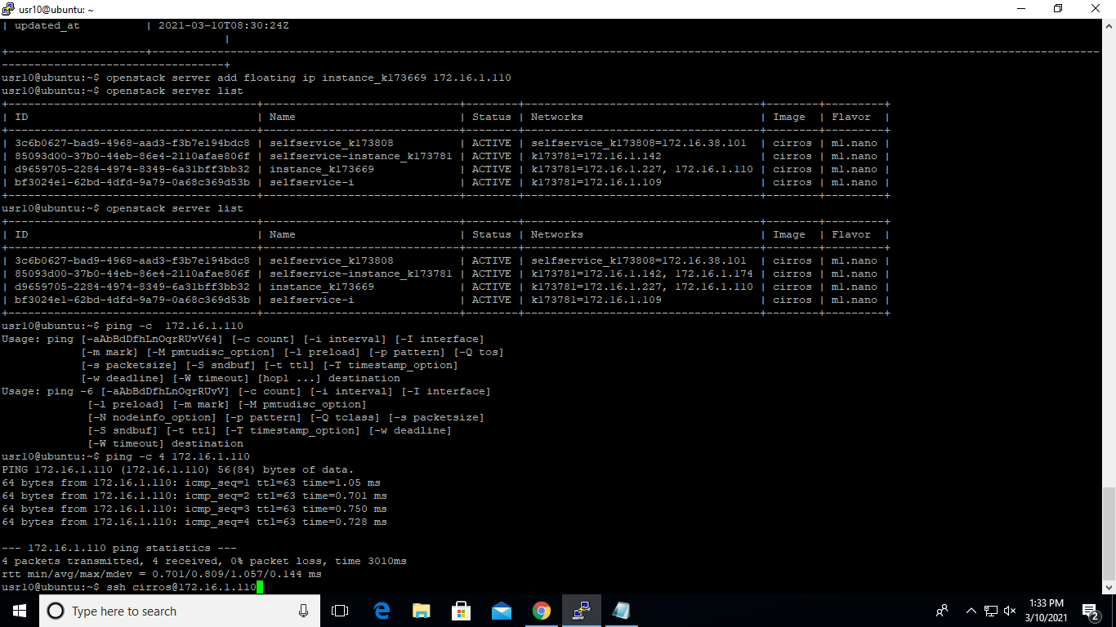Discovers his growing powers as he and Saena venture

Into the forest to investigate their foe and find the root

To the decay of the land; he must ultimately confront the

Truth that his mother was a Dark Fae and was responsible

For introducing a sickness to the human race.

**Answer 2.**

**Sales Table**

|  |  |  |  |  |  |  |
| --- | --- | --- | --- | --- | --- | --- |
| **Region** | **District** | **Store Name** | **Employee**  **Name** | **Customer Count** | **Cost** | **Sale** |
| **± Ali** | **Total** |  |  | **153** | **9724** | **13149** |
|  | **± Ahmed** | **Total** |  | **153** | **9724** | **13149** |
|  | **± Imtiaz** |  |  |  |  |
|  | **Ayaz** | **53** | **611** | **830** |
| **Wajahat** | **40** | **731** | **1429** |
| **Maaz** | **60** | **8382** | **10890** |
| **Total** |  |  |  | **153** | **9724** | **13149** |

Answer 3.

**3.1 Performance measures**

**Let {*Q*1,…,*Q*q} be the set of query images. For the *i*-th query *Q*i let *li(t)*,…,*l(t)ai***

**Are correct answers and rank (*li*(t)) is the rank of *lj*(t) in the result. We use three performance measures [7]:**

1. **Avg-r= $\frac{1}{q}\sum_{i-1}^{q}{\frac{1}{a1}}\sum_{j-1}^{ai}{}$ rank (*lj*(i)).**
2. **Avg-p= $\frac{1}{q}\sum_{i-1}^{q}{\frac{1}{ai}}\sum_{j-1}^{ai}{}$ $\frac{j}{rank(l)}$**
3. **Recall vs. Scope: For query Q1 and scope S(S>0):**

**Recall r= | {*lj*(i) |rank(*l*j(i))≤ S} |/ai.**